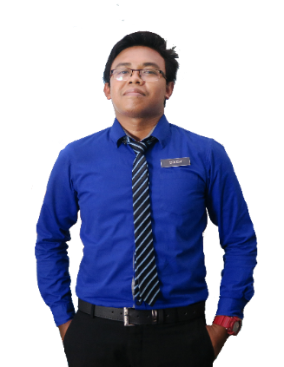

MALAY

ENGLISH

TAMIL

01

02

03

**LANGUAGE**

**ACHIEVEMENT**

* Successfully completed EduCare for Education Programme under Child Protection for International School
* Council of British International Schools (COBIS) Training

**SEKOLAH MEN KEB TUNKU AMPUAN DURAH**

**English Language Teacher (Practical)**

Practicum Teacher for English Language Form 2 and Form 4 Class.

**May 2013 - August 2014**

Worked with students who have a wide range of learning, mental, emotional, and physical disabilities. They adapt general education lessons and teach various subjects, such as reading, writing, and math. Gained experience assisting students with a range of disabilities and learning differences, including ADD, ADHS, autism spectrum disorders, dyslexia, cerebral palsy and Down syndrome.

**Oct 2013 - Mar 2015**

**Speech Therapist and Academic Teacher**

**LOUIS CENTRE FOR CHILDREN’S WITH SPECIAL**

**NEEDS SEREMBAN**

Malay language Teacher for Second Language Learners. Teaching Bahasa Language for second language learner using Malaysian Syllabus. Teaching basic reading and writing by using correct grammar structure as for daily basis. Using “Approaches to Language Teaching and Learning” method to teach Bahasa for the second language learner.

**Apr 2015 - Apr 2019**

**Teacher**

**MATRIX GLOBAL SCHOOL, NEGERI SEMBILAN**

**EXPERIENCE**

Sijil Pelajaran Malaysia (SPM)

**SEKOLAH MENENGAH KEBANGSAAN PUTERI, NEGERI SEMBILAN**

**2008**

Foundation for B.Ed TESL

CGPA: 2.71 / 4.00

**UNIVERSITY SELANGOR BESTARI JAYA, SELANGOR (UNISEL)**

**2014**

MUHAMAD SOLEH HUDIN

25 years old, male, single, ISLAM , Malaysian, 24 august 1991

I am an accomplished TESL Graduate with a background in teaching primary up to secondary level. Ability to integrate theoretical concepts and practical ideas, apply them to actual classroom situation. Proven abilities in working with a wide-range of age levels providing appropriate and creative instruction.

Bachelor of Education (Honors) Teaching English as a Second Language

CGPA: 2.45 / 4.00

**UNIVERSITY SELANGOR BESTARI JAYA, SELANGOR (UNISEL)**

**2016**

Hardware Engage System

SMART Notebook 15

**ANDREW HAMILTON**

Head of Primary (International)

Matrix Global Schools.

[Andrew.h@matrixschools.edu.my](mailto:Andrew.h@matrixschools.edu.my)

+6016-3324426

**TRACY CHERYL FRANCES SEQUERAH**

Human Resources (International)

Matrix Global Schools.

[tracy.s@matrixschools.edu.my](mailto:tracy.s@matrixschools.edu.my)

+6019-6002362

No. 2465 Jalan SJ 2/2 Taman Seremban Jaya, 70450 Seremban, Negeri Sembilan.

resumecreative@gmail.com

**PERSONAL SKILLS**

Leadership

Communication

Teamwork

Adobe Photoshop

Microsoft Office

**SKILLS**

**CONTACT**

+6013-2805916

**REFERENCES**

**EDUCATION**